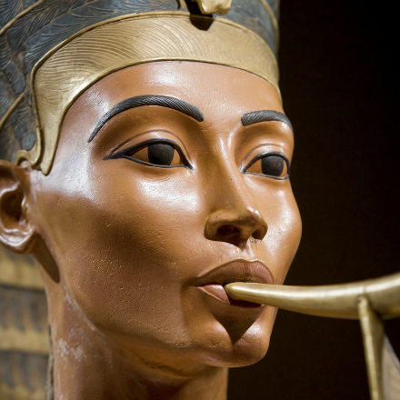 Heritage   
Happenings

**January 2025  
The monthly newsletter published by residents of   
Heritage on the Marina, San Francisco CA, USA**

# Egypt

The January country of the month is Egypt. The colors of the Egyptian flag are red, white, black, and gold. The masthead cameo this month is an artificial intelligence image of Nefertiti, a queen of ancient Egypt blowing on a “Horn of Tutankhamun”. The concept is based on the famous sculpture of Nefertiti in Berlin.

This issue contains three articles and a book review about Egypt. Dining Service will feature an Egyptian Dinner on January 17. Fingers crossed: we may have a performance of Egyptian music.

The February country of the month is China—not forgetting that Lunar New Year, the year of the snake, actually starts on January 29 in 2025.

The Lunar New Year 2025 brings with it the arrival of the Wood Snake, a rare and significant combination that occurs once every 60 years. This unique pairing of the snake, known for its wisdom and transformative energy, with the wood element, symbolizes growth, stability, and creativity.

Have you been to China? Do you have a favorite Chinese restaurant? Is there a dish you crave?

In March, the country of the month is Ireland, of course, so we can all wear green on Saint Patrick’s Day and taste some Guinness Stout.

## What’s to Laugh About?

Looking at newsletters published by other “wrinkly homes,” I often see humorous snippets sprinkled throughout. Many of the items are simply text and images copied from other publications.

I mostly resist outright copying. As a software programmer, I worry about reusing other people’s intellectual property without permission. So, instead, do we residents have our own funny things to say?

You have a laugh? We can publish!  
*Theo Armour*

# Dear Residents,

I hope this message finds you well and that you had a joyful and restful December. I know the holiday season can be busy, but I trust that you have had moments of relaxation and reflection.

As we close out 2024, I want to express my sincere gratitude for our dedicated team of leaders and staff, whose compassion and care for our residents continue to shine. We are proud to have completed a deficiency-free survey from the Department of Social Services, especially given that Aging in Place is still a relatively new concept in California. We are honored to be at the forefront of this important movement. We are also making great strides with our new Yardi software, which will soon support our finance, human resources, maintenance, and nursing departments. Additionally, we are on track to secure our land use permit. Finally, we are thrilled to share that our application for Landmark status for the Julia Morgan building has been approved. We expect to receive formal designation from the new Mayor in the coming weeks. Finally, last week we sent out an email blast to residents and neighbors with an updated FAQ about our strategic plan. This can also be found on our website under “future plans.”

Looking ahead to 2025, I am hopeful that we will continue to engage in respectful and meaningful conversations. It is a privilege to serve the Heritage community, and I deeply appreciate the active involvement of our residents.

Here are a few important events:

**January 22, 2025, at 10:00 AM:** We will hold a special financial meeting to address questions regarding our status as a 501(c)(3) private charity. Per your requests, we will have legal counsel and a tax accountant present. We will also provide an update on savings and expenses following the closure of the SNF (skilled nursing facility) on April 1, 2023. Board members have been invited to attend.

**February 12, 2025, at 10:00 AM:** Our semiannual meeting will be held to discuss the 2025 budget, resident fee increases, and other community updates.

**March 27, 2025, from 2:00 to 4:00 PM:** We will celebrate the 100th anniversary of the Julia Morgan building with a special event. This will be an opportunity to showcase our community to local residents and politicians and will also serve as a fundraising event.

On behalf of our staff and myself, I wish you all a Happy New Year. May the year ahead bring you good health, happiness, and peace.

Warm regards,

  
Mary Linde

Chief Executive Officer

|  |  |
| --- | --- |
| Heritage Happenings The monthly publication published by residents of [**Heritage on the Marina**](https://heritageonthemarina.org/)  Editor Emerita  Margaret Jacobs  Editor  Theo Armour  Associate Editor  Mia Cotton Harlock  Editorial Committee  Jane Standing  Martha Nell Beatty  Doris Howard Tom King Margaret Missiaen  Reporter at Large  Trish Otstott  Proofreader  Midge Mansouri  Website  [**heritage- happenings.github.io**](https://heritage-happenings.github.io)  General Disclaimer  The views and opinions expressed in this publication are those of the authors and do not necessarily reflect the official policy or position of Heritage on the Marina.  © 2025 *Heritage Happenings* authors.  No rights reserved. | Community Engagement  When I walk around my Marina neighborhood, I see many older adults, but sadly, I don’t know any of them. At concerts or lectures in Friendship Hall, I also notice plenty of empty seats. This makes me wonder if there’s a way to bring the two groups together. I’ve been considering inviting some of our older neighbors to attend our events, and the staff supports the idea.  In pursing this goal, I’ve also joined and met with Next Village SF, a neighborhood nonprofit that helps older adults live independently. They have about 300 members and 200 volunteers. In 2024, they held 755 member events and volunteers handled over 2,800 service requests—pharmacy pick-ups, rides to doctors, check-ins, and more. Most members live in North Beach and the Marina, so they really are our neighbors.  As a first step, on January 24, we’ve arranged an architectural tour that I will lead of the Julia Morgan building and campus for Next Village members. While they’re here, I’ll see if any would be interested in attending our events.  I’ve found Next Village to be well organized, well managed, and excellent at communication. I look forward to exploring ways that Heritage on the Marina and Next Village can help one another. If you have any ideas about meeting people our age or would like younger volunteers to visit or run an occasional an errand for you, please contact me.  Theo Armour |

# Monthly Health Topics

By Theo Armour

As Anne Morris reminds us, "Growing old is not for sissies."

Being one of the youngsters around here, I like to think that Heritage is actually an elite training school for learning to age gracefully and I am a student. As with any good school, the curriculum is broad and deep. Aging well must consider a wide range of topics.

## Topics of Study

My niece Mia is helping me with my studies. In her lesson plan, she divides the year into twelve monthly topics of wellness studies. Here are the subjects we will study:

* Exercise (Mental & Physical)
* Sleep
* Eating Well & Hydration
* Healthy Relationships with Yourself & Others
* Socializing
* Hobbies, Passions, Inspiration
* Financial Fitness
* Advanced Planning
* Fall Prevention
* Medication Management
* Community Engagement
* Your Legacy

I will share my homework with you in the coming months. I hope you'll share your thoughts and experiences with me, too.

Also, as part of my efforts I hope that Martha, Vada, Brittany, Jonathan, and others will help me with my studies so that I can include their thoughts and experiences in the newsletter.

Practice What You Preach  
But the most important thing, is that I will try to practice what I preach. I will share my experiences with you in the newsletter. I hope you'll share your thoughts and experiences with me, too.

## Why Study All This Stuff?

I will be 78 this month—older than the average life expectancy of 76 for males in the US. Obviously, I am a success in the aging department. But there are numerous residents here that are twenty years older than I. Way more successful! Why do we even need to bother with all this stuff?

## As Ye Sow So Shall Ye Reap

The actions I take, whether good or bad, will have consequences that I must face later. But guess what? “If it’s no fun, I don’t do it.” Therefore, I seek actions that I enjoy doing today that will also help ensure enjoyment for my future self. There is so much more to discuss. And that is why I plan to write a page every month on aging well.

Here’s to aging well, celebrating our successes, and supporting each other every step of the way.

# Time to Move

By Theo Armour

Hippocrates in Ancient Greece **observed** "Eating alone will not keep a man well; he must also take exercise.”

Studies in the 1950s compared the health of London bus conductors and London bus drivers who lived in the same environment. The only difference: the bus drivers were sitting; the conductors were standing. The heart disease rate among the drivers was twice that of conductors. **Evidence** of the benefits of exercise at last.

The modern breakthrough is that researchers are now gathering **actual proof** of the benefits of exercise, down at a molecular level.

Euan Ashley is a professor of cardiovascular medicine and genetics at Stanford University and the new chair of its Department of Medicine. Stanford is part of a massive study revealing why exercise is so good for our health. Dr Ashley discussed the benefits of exercise in a recent PBS interview. The following bullets are highlights:

* The first study was rats that were sedentary and then trained over the course of eight weeks with aerobic training on a treadmill. They turned into almost different beings—exercise was that potent. Every single tissue we looked at showed something completely different from before. It really changed the entire molecular makeup of the individual organs of the rats in a very positive direction.
* Exercise is a remarkable intervention, essentially reducing the risk of heart disease and many cancers by 50 percent and reducing back pain.
* People sleep better. They are in a better mood. They're able to breathe better.
* If you can walk, go for a walk. If you can get 20 to 30 minutes of moderate intensity exercise five, six times a week, that's fantastic. Any movement is better than none.
* One minute of exercise buys you five minutes of extra life, which means you definitely have time to exercise.
* The time doesn't matter, and particularly good after meals.
* But the main thing is to get up, move about as much as you can.

Here at Heritage on the Marina we are so fortunate to have coaches, climate, and location all working in our favor. I like solitary exercise. Many people like to work out in a group. The main thing is to get up from your chair once or twice an hour. Stand up in between hands of solitaire. Watch TV standing up. Take a stroll between each chapter.

Hint: Set some goals. Decide what to track. Keep a score of your efforts.

# Training for the Holidays

By Tom King and Val Szigeti

We took a train to Tahoe for Christmas. What a glorious trip through the snowy mountains!



The train was smoother and quieter than we had imagined, and all the Amtrak people were friendly and helpful despite this being one of their busiest days of the year. Once the train got past Sacramento into Colfax, the scenery changed from Central Valley yuck to snowy Sierra wonder.

OK, the train actually left from the Emeryville Amtrak Station, and then we got off in Truckee amidst huge snowflakes and holiday music in the square. Our smiling daughter-in-law, Jennifer, ran to meet us and then chauffeured us from Truckee to their ski place in nearby Martis Camp, where we joined 11 people for the holidays, starting with a Christmas Eve feast.

Christmas morning had us participating in a traditional Catalan opening of presents — five of the guests were relatives from Barcelona. The tradition, based on an early pagan ritual, starts with a song and includes hitting a puppet-like log with sticks until it poops out the first present.

Here’s a picture of some of the kids and the presents patiently awaiting them under the tree:

  
After lunch, we walked around a small lake, played with the kids (and their new toys), and enjoyed the snowy vistas out the windows.

Coming back had Tom driving a rented Jeep Wagoneer with five passengers through a snowstorm with chain controls on a busy and slippery I-80. Where’s the train when you need it?

Egypt’s Siwa Oasis

By Martha Nell Beatty

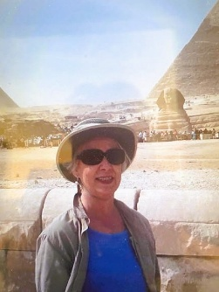In 1972, my husband Denis and I organized a trip to Egypt. We included the musts, but Denis, who had lived in Egypt in the late ‘70s, suggested we include the little-known Siwa Oasis in the western desert. But why Siwa?

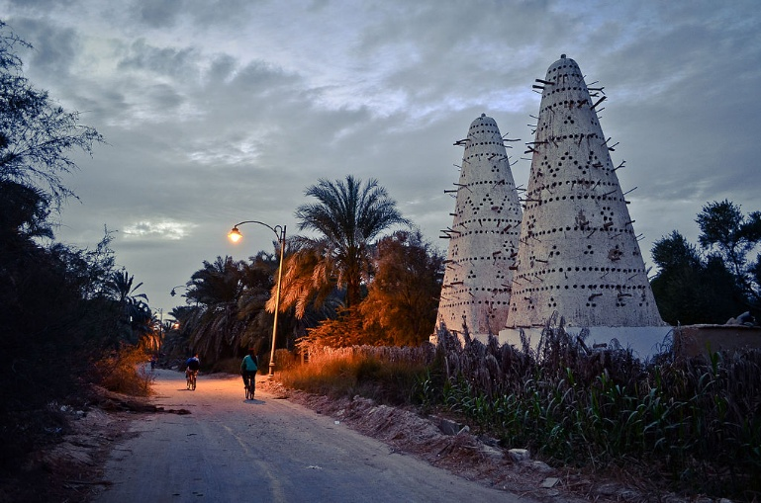It’s famed for historical reasons. The Temple of the Oracle of Amon is where Alexander was acknowledged as the son of Amon-Ra, the supreme god. Siwa was one of the seven most revered oracles in ancient times and the only non-Grecian one. Pharaohs felt the need to make the arduous trek to Siwa.

Cleopatra supposedly bathed in one of the many pools known for their therapeutic properties. Cleopatra Pool is believed to have been given to her by Marc Anthony.

It’s a place of serene beauty with its groves of palm and olive trees, saltwater lakes and springs, and sand dunes. Perhaps part of its allure is its remoteness. It’s not available to day trippers.

Our group of 15 set off for Siwa in a mini-bus with our driver, our guide, and an armed guard. To get to Siwa we traveled to the Mediterranean coast, where we stayed overnight in Alexandria. Then south along the Libyan border.

After visiting the fascinating sites and taking in the beauty, we arrived at our guest house. There we were greeted by a very pregnant woman, who later waited tables and also tended to the guest rooms. While we waited for our rooms, one of our tour members, a doctor, decided to make a visit to the kitchen. He came out warning us to eat as little as possible as conditions were definitely not hygienic. We nibbled on our dinner, concentrating on stringy chicken and rice.

Our rooms did not look appealing or clean. I’m not even sure we changed into our night clothes, but I recall that we slept fitfully on top of our bed coverings. The next morning, we were all up and ready to go before our breakfast time. After a hasty meal, we boarded our bus. As we were about to leave, one of the staff rushed out with box lunches. They were so hospitable and kind, but we couldn’t wait to get to Marsa Metruh on the Mediterranean for a welcome lunch.

Our group never complained. They seemed to appreciate our desert venture as something unique and special. Something to talk about when home.

# Bordeaux Wines

By Patrick Alexander

Last November I spent a week in Bordeaux France. Bordeaux is at the heart of one of the best-known French wine producing areas.

Just north of Bordeaux are two of the most famous vineyards, Chateau Mouton Rothschild, and Chateau Lafite Rothschild. They are neighboring wine estates owned by separate branches of the Rothschild family.

Expect to pay about $1,000 for a bottle of wine from either of these estates. Their production is limited, and the quality is extremely high. So, over the years their reputation has grown and the wine, when available, is highly sought after. They primarily produce red wine from Cabernet Sauvignon and Merlot, and use other types of grapes as well.

A description of the difference of their wines, coming from a wine commentator, was that Chateau Lafite Rothschild was described as elegant and austere, while Chateau Mouton Rothschild is considered opulent and fruity.

The estates themselves are not exceptionally large. Chateau Lafite Rothschild is 112 hectares or about 277 acres. Chateau Mouton Rothschild is 90 hectares or about 222 acres.

The English will refer to red wine as “Claret”. This comes from an old French word *Clairet* which means clear, light-colored red wine.

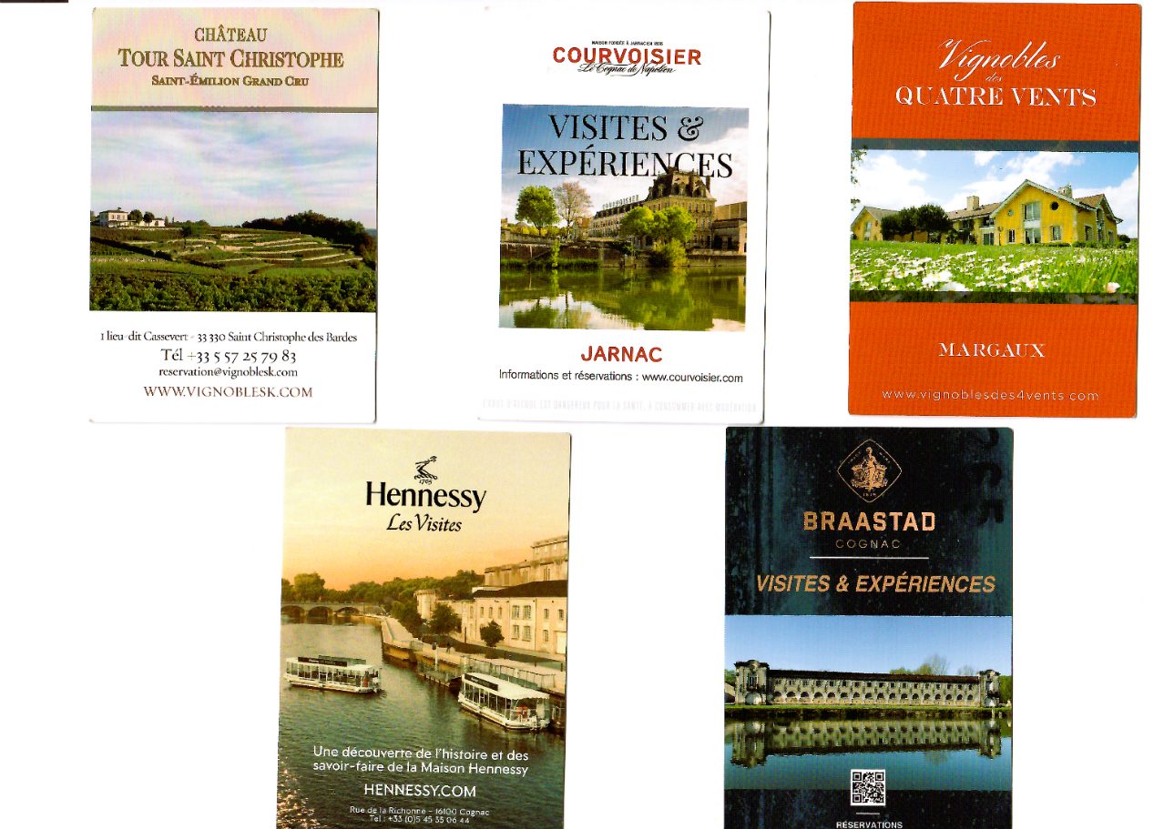

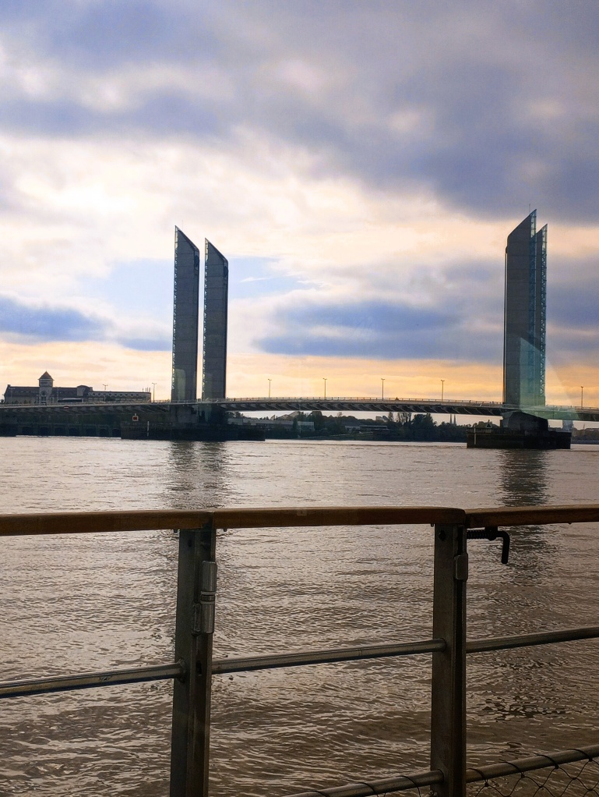

In the northern part of the city of Bordeaux is the “Cité du Vin” – the City of Wine. You can either take the tram there or go by boat down the river Garonne. There are river departures on a regular basis from the city by a get-on get-off ferry called “Le Batbus” which will drop you at the Museum of Wine. See the next two images!  


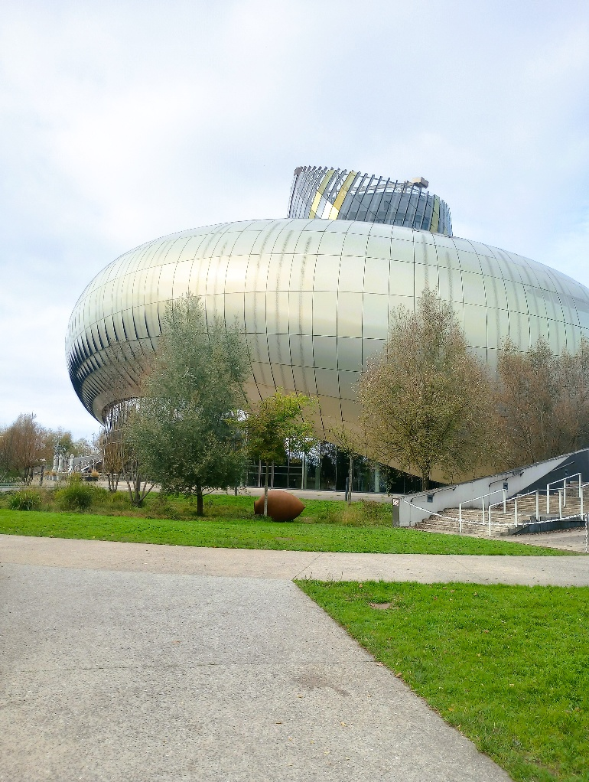

There are also many tours to other wineries and *chateaux* in the region. On the opposite page is a collage of some of these places, the details of which I picked up at the Museum of Wine.

# ~ ❧ ~

Patrick reports that both Til and Terry were members of the "Sewer Club" in the Financial District. According to Terry there was this quotation above the bar:

"Life does not flourish in an Empty Glass."

# Safari in Tanzania

By Margaret Johnson

In 2006, I offered my son Tom, as a 60th birthday present, a trip to anywhere he would like to see, as long as I could go with him. He chose a safari in Tanzania. At 82, that was okay by me! We flew from London to Dar es Salaam, on the way seeing Mt Kilimanjaro poking above the clouds. At the rather mildewed, chaotic airline terminal we found that no one knew anything about us, which was kind of scary because we thought we were in a tour group. But we were rescued by a man from an internal airline who got us sorted out and onto a single-engine 14-seater headed for Selous Safari Camp, the first of our three camps.  
The plane dropped us and our bags at a deserted dirt strip surrounded by scrubby forest (“miombo”), leaving with a cheery, “someone will be by soon to fetch you.” And before we got too nervous about being eaten by wildlife, a jeep did arrive. On the trip to the camp, when we got excited at seeing some impalas and giraffes, we were told to relax— we would see zillions in the next few days, and indeed we did.

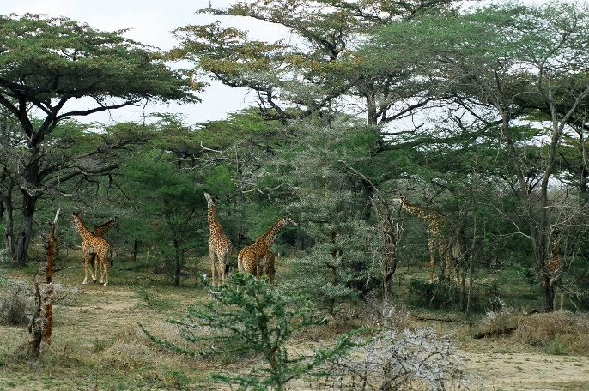

Our hosts, a young American couple, introduced us to our guide, our butler, and our houseboy(!), and immediately loaded us onto a boat on an oxbow lake of the Rufiji River. The trip was fascinating: on the river we saw a herd of hippos (well, ears and nostrils), dozens of crocodiles, and elephants drinking and bathing, and in the woods were impalas, reedbucks, a waterbuck, cape buffaloes, and giraffes. And the birds! Hadada ibis, spoonbills, fish eagles, yellow-billed storks, a goliath heron, egrets, and Egyptian geese to name just a few. We saw as much wildlife in two hours as we had hoped to see in a week. An impressive start! That afternoon we went on the first of the numerous game drives of the next nine days, getting up close to a herd of elephants, seeing monkeys, baboons, a hyena, and getting a really great education from the exceptionally talented guide.

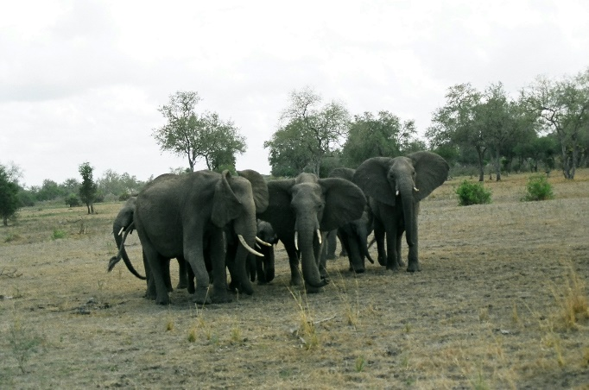

The whole place had a Polynesian look, with high-pitched thatched roofs. The community rooms - library/bar and dining room - were raised about 10 feet above the ground and open all around with a view of the lake. Our platform—mounted tent cabin was quite comfortable, even luxurious, but when darkness fell that first night, we knew we were in the jungle — all night long there were loud snufflings and rustling **right** outside the tent as hippos and other large animals foraged through the camp. We were told never to leave the tent for any reason at night, were escorted to and from our tent by Masai staff and provided with a whistle to call for help if needed. After the morning bird chorus our butler would arrive with a tray of coffee and biscuits balanced on his head for us to enjoy on our porch. It was very exotic.

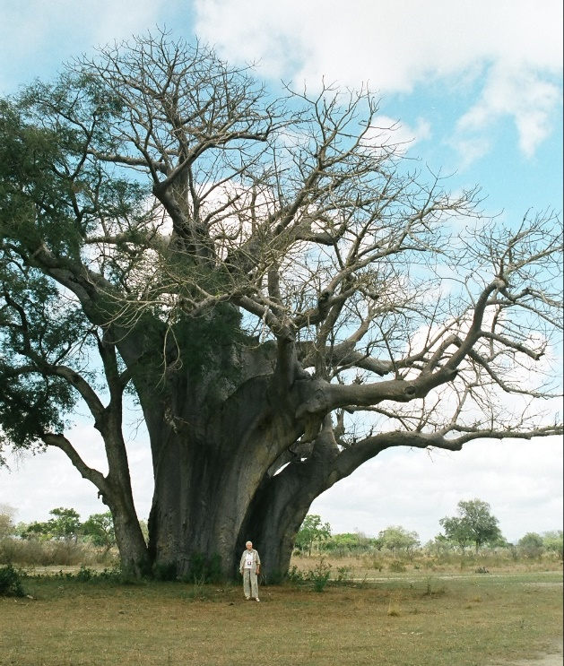

Highlights of our Selous experience included our first baobab tree (a surreal experience – they look as if a thick syrup had been poured on an upside-down tree and then solidified), a group of lion cubs whose parents totally ignored us, an educational walk (our guide carried an elephant gun to “reason with” wildlife), the grave of Captain Selous, killed in WWI leading African militia against German troops, and classic, Hemingwayesque African savannah. Back at camp, we found a young elephant browsing the trees next to our cabin. I suggested that my only son would get a better picture if he walked past the animal to the porch – fortunately, that worked out OK.

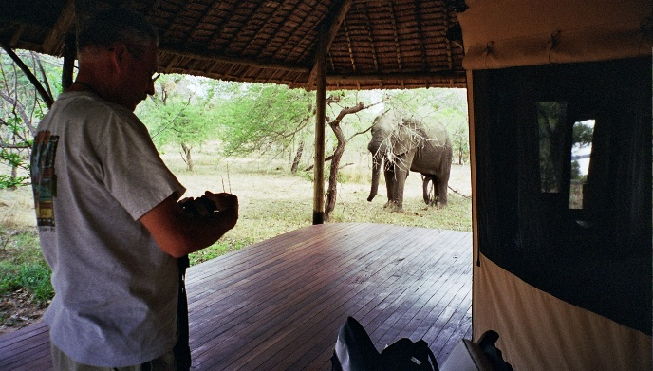

The rest of our trip, to safari camps in Mikumi and Ruaha National Parks, was at least as exciting as Selous, and perhaps there can be a second installment of this narrative.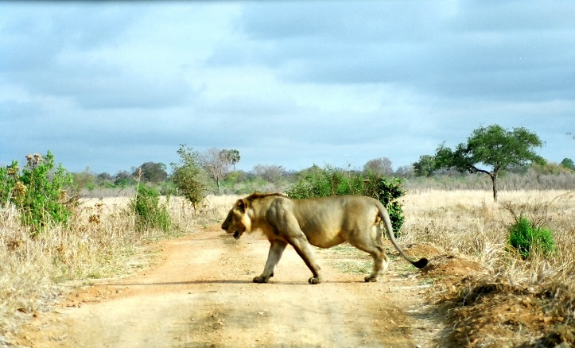

# The Pyramids of Egypt

By Sheila Moore

I believe I've visited Egypt three times, and 2010 was the second time, but I'm not sure. Each time I've visited, Egypt does seem to be more developed and prosperous. I usually stay downtown in some cheap crummy rooming house, and take a local bus to Giza, on the outskirts of Cairo, where the famous Pyramids are situated.

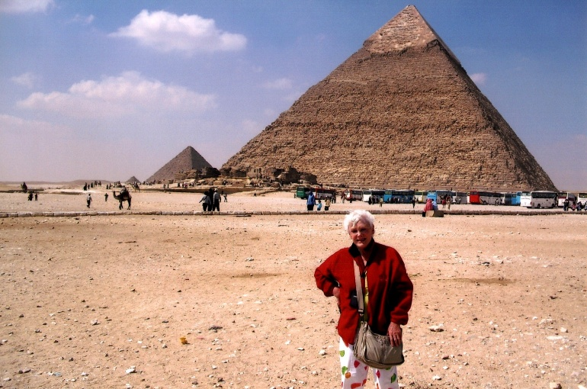

This is the main Pyramid. It's huge, and about 4,600 years old.

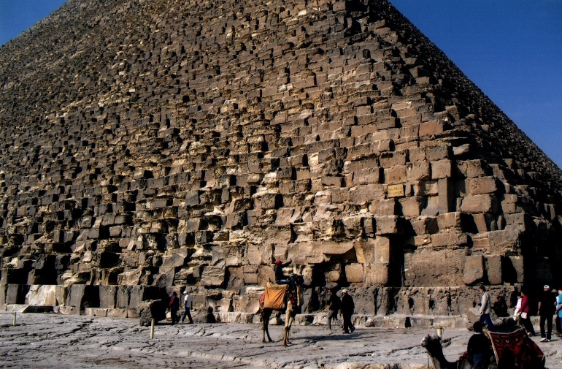

The outer veneer or cover has been worn off or weathered off, and the facade is of great blocks of granite. Years ago, on a previous visit, I paid a man a tip to see him leap up the blocks to the top, and back again. It's how he made a living.

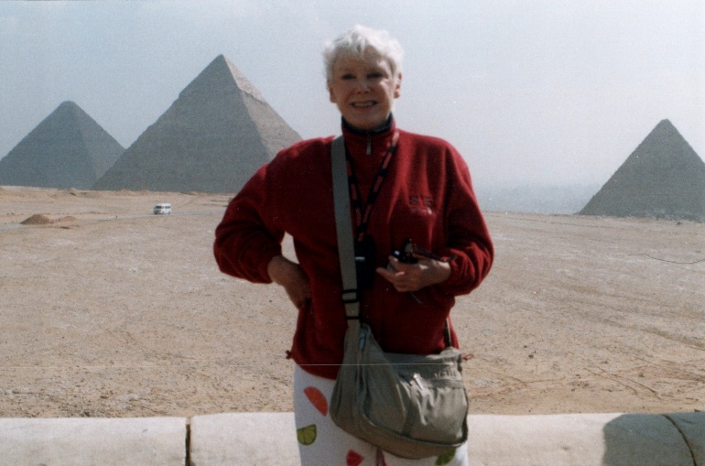

For a fee, a visitor can go inside the pyramid, and on one of my trips I did go inside. The Pyramids are huge, 4,600 years old, and one of the Seven Wonders of the World.

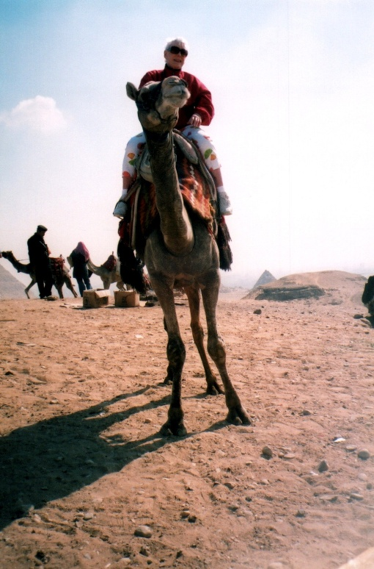

Me on a camel. But I soon found out the camel had a mind of its own and was strong and twisting around, so I didn't stay on it long.

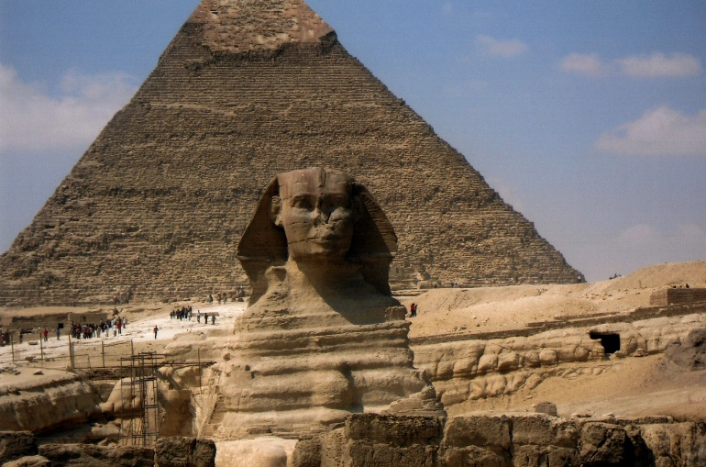

Next, I visited the Sphinx, which is a little downhill from the Pyramid. The Sphinx has a feline body of a lion, with the face of Khufu, Cheops in Greek. It is carved from a single stone. French troops damaged the Sphinx' face by firing on it.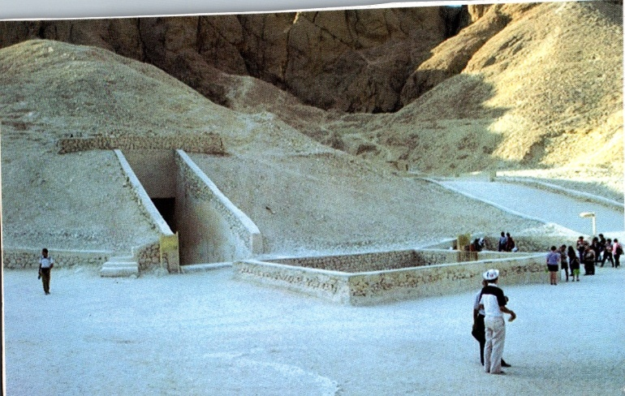

Next, I took a bus and stayed for a few days in Luxor, which has many ancient temples. Then I took a local barge and crossed the Nile River and walked to the Valley of the Kings. There were many tombs — here is the entrance to King Tutankhamun's Tomb ($20 entrance fee).

To the right: Full view of the inside coffin covering the mummy of King Tutankhamun.

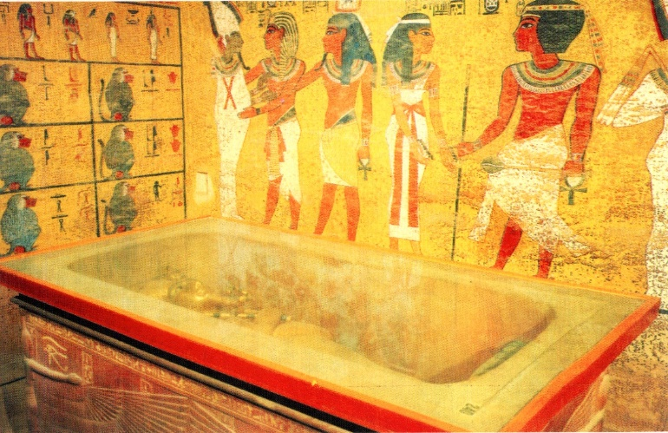

Inside the inner burial chamber of King Tutankhamun's tomb. His tomb had several layers - one box inside another. A golden gilded coffin enclosed his mummy.

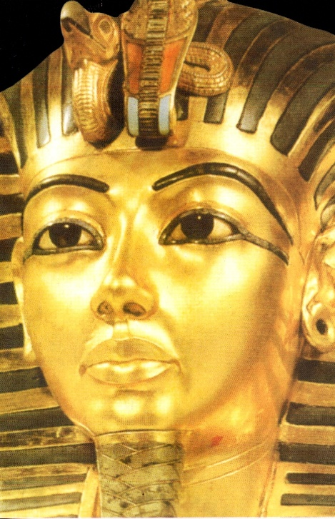

The beautiful, gilded mask covering the mummy of King Tutankhamun.

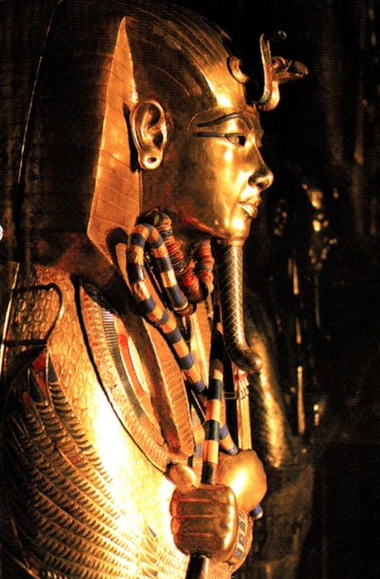

# Cairo - September 1980

By Doris Howard

There are two memories I have of that week in September 1980. One is walking along the Nile River, where it flows through the city along beautifully designed embankments, moonlight, and pale city streetlights. Beautiful!



The other memory is more mundane. I had heard of people bargaining on foreign bazaars but never thought I would find myself doing it. I was sitting in one - a string of jewelers, waiting while others shopped. I noticed a silver chain in an unusual pattern, so I got up to look at it. A salesperson promptly emerged and offered it for $100. I refused the offer. He said "$80". I said, "No. No. I have several silver chains". He said "$60". I said "No". He said "$40". "No." He said "$20". I bought it. I realized I had just done what others had bragged about: I bargained!

I wore the lovely silver chain that evening. When I removed it later, I found a green stain ringing around my neck.

Not such a bargain, after all!

# Library Corner December 2024 New acquisitions

By Martha Nell Beatty

***Fairy Tale* ~ F ~ 2023**

Stephen King

A 17-year-old inherits keys to a hidden, otherworldly realm and finds himself leading the battle between good and evil.

***Sasquatch: Legend meets Science* ~ NF ~ 2007**

Jeff Meldrum

A scientist with impeccable credentials reviews the mystery of an undiscovered North American primate. See Tucker’s revue.

***Hour Game* (King and Maxwell series) ~ F ~ 2023**

David Baldacci

A mystery thriller that goes in unexpected directions

***Empress of the Nile: The Daredevil Archaeologist Who Saved Egypt's Ancient Temples from Destruction ~ NF ~ 2023***

Lynne Olsen

See the book review by Doris in this issue. This book is the January selection for the Book Club.

Book Reviews

by Tucker Ingham

The Wide, Wide Sea, Hampton Sides

Was it, by any stretch of the imagination, a justifiable homicide? That’s the question central to The Wide, Wide Sea regarding James Cook’s murder in Hawaii in the last quarter of the 18th century. With copious research and a voluminous bibliography, we are left pondering. Among Captain Cook’s officers were William Bligh (of Mutiny on the Bounty fame) and George Vancouver, for whom two cities and one of Canada’s largest islands are named. Captain James Cook remains one of history’s most prolific cartographers and explorers who solved some of the world’s most nagging puzzles. At his death, he would have been understandably exhausted, fatally so, as was Ferdinand Magellan, killed in the Philippines 258 years previously.

The Wager by David Grann

In the final quarter of the 18th century, England, embroiled yet again in war with France and Spain, dispatched a squadron of warships to the east coast of South America with the intent to capture one of the vessels loaded with gold and silver mined in the Andes. The mission succeeded, but in the process, one of its escorts, the HMS Wager, was forced by severe weather onto a reef off Chile, where it sank, with most of its crew stranded without help, presumed drowned as collateral damage but barely surviving. Against all odds, David Grann relates the harrowing ordeals of the crew members as they miraculously return to England in two separate groups, the first around the Horn and into Brazil to avoid Spanish capture, the second northward toward Peru, still Spanish but at peace with England, fortunately.

Sasquatch by Jeff Meldrum

The persuasive power of legend is thoroughly examined. The mythical Bigfoot phenomenon was launched successfully in 1958 by three co-workers on a road construction site, Ray and Shorty Wallace and Rant Mullins, who carved the wooden giant feet convincingly used to leave the formidable tracks in numerous mountain meadows.

The public supplied ample proof of the Sasquatch with videos, fur samples, scat, and earnest anecdotes. Were the three perpetrators guilty, or were they merely bringing attention to an actual anthropological mystery? This book leaves readers with the question enigmatic.

“Two Dead in Pursuit of Sasquatch”

San Francisco Chronicle, 1/30/24

Two men, aged 40 and 60, were found in the mountainous forests of Washington State lying dead days after reported missing by family. They were hunting for the fabled Bigfoot believed haunting the vicinity by many.

# Empress of the Nile: The Daredevil Archaeologist Who Saved Egypt's Ancient Temples from Destruction by Lynne Olson

Review by Doris Howard

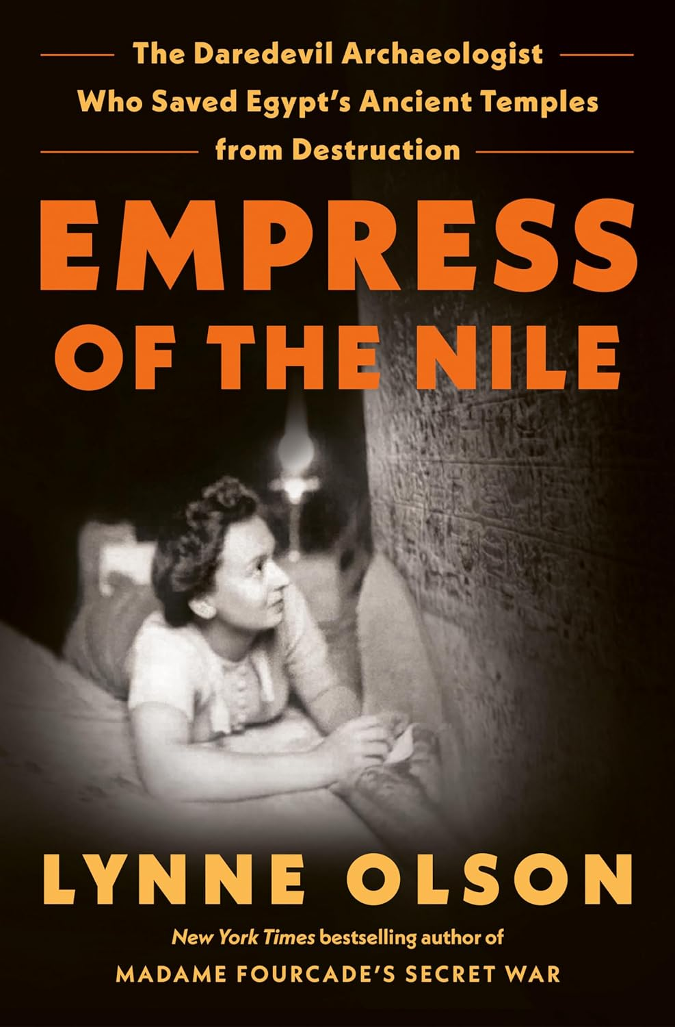This biography deserves a more dignified title. It is a comprehensive history of the career of the French archeologist, Christiane Desroches-Noblecourt. She was an Egyptologist who did fieldwork, taught and was the director of Egyptian antiquities at the Louvre. This does not even begin to describe the breadth of her life's work. In the course of pursuing her extensive fieldwork, she interacted with Egyptian authorities, overcoming historical hostility toward the French because of past exploitation and acquisition of antiquities. As her career spanned the 20th century, she also had to overcome resistance to women from male peers and Egyptian authorities.

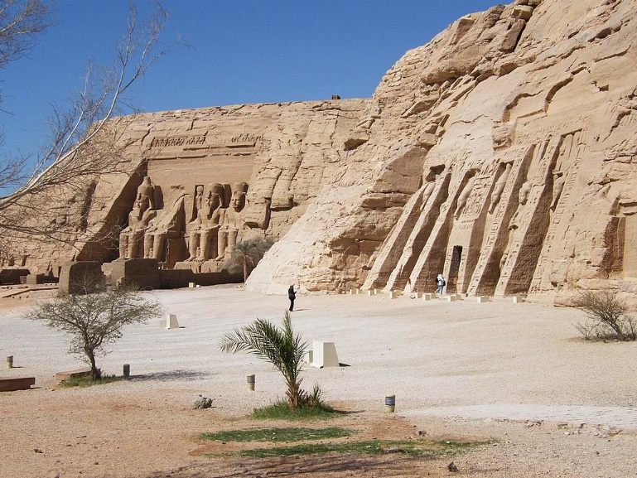

In the 1950s, when Egypt was planning to build the Aswan Dam, it was Christiane who worked tirelessly to raise money to save the famed statues at Abu Simbel. Abu Simbel is a huge temple built thousands of years ago by Ramses II in his own honor. It was threatened with burial by the waters of the Nile River in 1960 when plans were underway to build the Aswan Dam. Christiane aroused Egyptians, Europeans and even Americans to the potential loss of the temple. She inspired hundreds to work toward saving Abu Simbel by taking it apart and rebuilding it on higher ground.

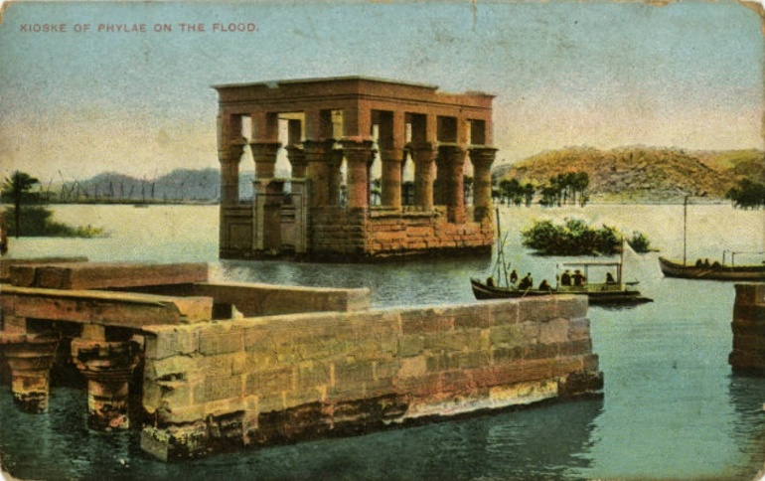

Then she accomplished the same with the temples on the island of Philae. The primary temple was dedicated to the goddess Isis, the center of a Mediterranean-world-wide religion. Christiane wrote a dozen books about Egypt and its history. A half-dozen books were written about her. There was a film about her produced in the 1980s. Her final efforts were in fieldwork in the Valley of The Queens — the extensive grave sites of the wives and children of the pharaohs. Most attention had previously been paid to the Valley of the Kings by earlier (mostly male) Egyptologists. She was interested in the women. Despite the pillage and loss of mummies in early centuries, she found many valuable artifacts.

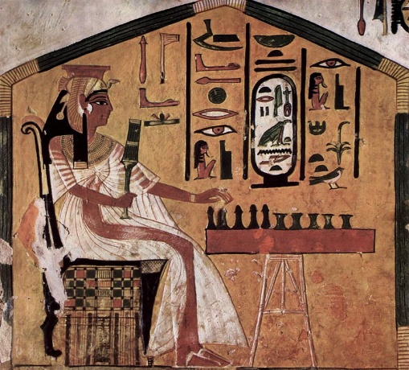

The author goes far afield to describe events that Christiane overcame. Describing the efforts to save Abu Simbel, the author wrote about concurrent world events, *eg*, the political tension and distrust between Western powers and the Egyptian presidency of Gamal Abdel Nasser. Nasser was trying to maintain peaceful relations with Russia and President Kennedy distrusted his motives. However, Christiane called so widely for financial assistance that Jacqueline Kennedy convinced Jack Kennedy to request United States funds for the project. Christiane not only won over other Egyptologists and politicians, she was a legendary worker in the field, both in her design of projects but also in her excellent relations with Arab workers. She learned Arabic and worked beside those digging and carrying.

This is a large, well-written biography of a strong exciting woman in an exciting profession. This is a book for all, not only for those of us who love archaeology. It is a book for those of us who love history and politics too.

# Miscellany

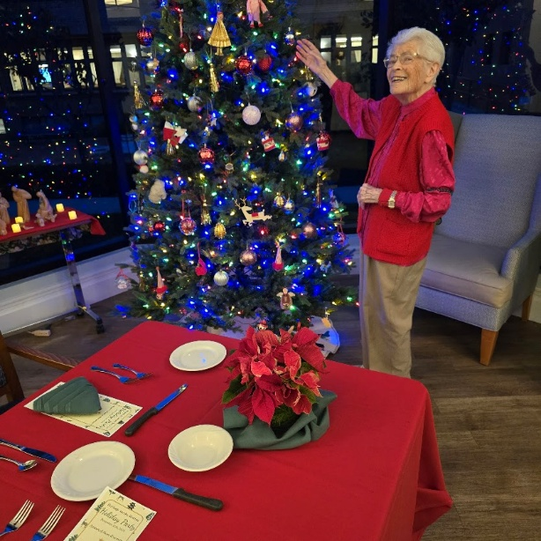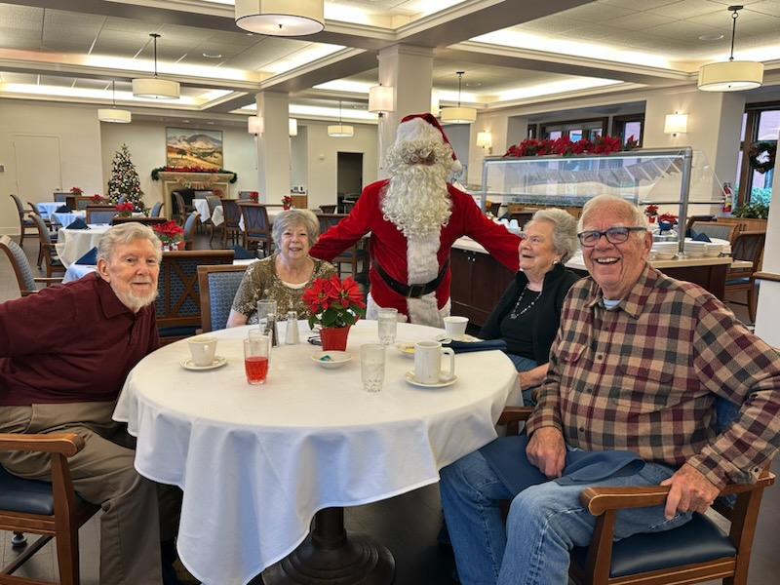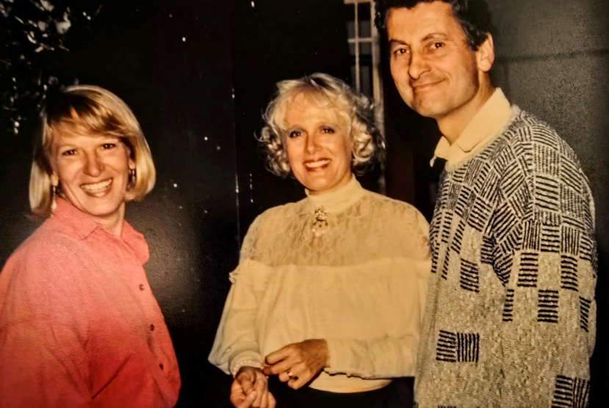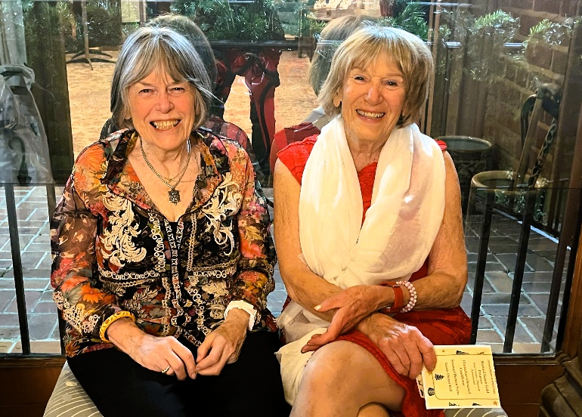

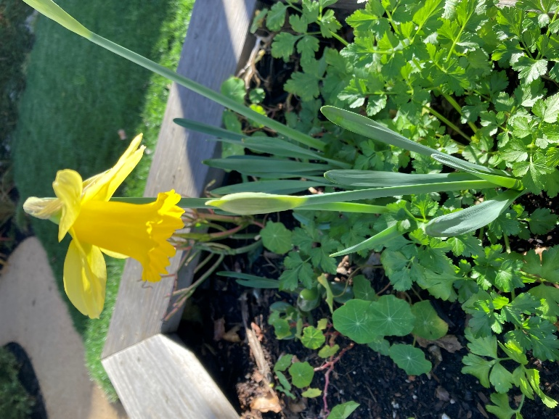

First daffodil of the Year